|  |
| --- |
| **SEN2001 – Programming Languages**  **Project Proposal** |
| **Project Group Members (Student IDs & Names):**  1.Aylin Görgün 1731920  2.Bahri Kaan Beşik 1731844  3.Betül Fatma Erkoç 1806499  4.Hakan Erenler 1608706 |
| **Project Category(Software Implementation Project / Tubitak Application/ Patent Application):**  Software Implementation |
| **Project Title:**  Entrecoor |
| 1. **Summary of your project (approx. 400 words, should include the summary and outline of the project as well as your study plans):**   Our project’s target audience is entrepreneurs who love to create something. As future entrepreneurs we asked ourselves, what may entrepreneur need? The answer to this question shaped our application’s features. This software will have 3 platforms to operate: Android, IOS and in web. We are planning to use a brand new platform called Flutter which uses the dart language and gets its support by Google. In our group, we have native android and native-IOS developers but according to the latest improvements in dart language and Flutter we decided to move on from here. When we were taking this decision we listened to our designer and took his opinions about material design upgrades and potentials in Flutter. We are thinking a basic but high-quality UI for entrepreneurs whose heads are full and probably does not want to see any complicated screens at least not when they are using our application. We are focusing the idea ‘Always have your basic tools in your hand*’ this is a very important step for creativity. We are planning to welcome our users with login or if they are new with a sign-up screen. When they are signing up we want to keep the name, age, their country and a very short bio. For keeping their data we found the Firestore as the most suitable option. We also considered Feathers and Meteor too but since we are using the support of Google we choose Firebase. Also, after signing in, user will be able to change their information. Keeping user information is important because we will also implement a board system. With this system, users will be able to plan their assignments. In our app, you can add multiple boards and in each board you can add multiple checkboxes as well. After you completed your assignments you can delete or set a reminder for your regular tasks. We are also considering to implement a sedentary alarm if the user chooses to use. All those notifications will be able to alert you even if the user exits our application. Also, users will be able to add their friends to their boards. In the main page, we also want to show our users Twitter’s TT list using Twitter’s rest API. And as and entrepreneurs ourselves we think being able to write our ideas with the most simple way is very important so in our app we will implement a FAB button to be able to write down ideas. You will be able to see them as a list, update and delete them. We will use sqlite to store this notes in your local storage and this means we will create a full CRUD circle. Also, entrepreneurs may need a place to distract them from their busy schedule, answer to this problem we thought about creating a fun zone. In this zone, you can expect to see a sudoku or tic tac toe game. Lastly, after researching more about an entrepreneurs’ essential websites, we will place icons to those websites. In web part, we will mostly use VueJs alongside with Vuetify or Bootstrap-vue. Skeleton will be the same but additionally, we will make a chatbot with Diaogflow. Replace fun zone with IO type games and since we have bigger screen our board system will be more horizontally designed. |
| 1. **Literature Review (approx. 10 examples)**   In order to make things easier to understand we are dividing our application to parts. Such as:  Board system, reading section, reminders, notepads and chatbots.  Probably the best way to explain what we mean saying board system is looking the idea behind it. The word ‘Kanban’ invented in the late 1940’s by Toyota. Kanban method is an answer for how to communicate with the group members, prioritizing your assignments, focusing and increasing productivity. The exact meaning is ‘better communication through visual management’ [1]. Simply if you write all of your assignments to separate post-its and stick them to a place which can be seen by everyone in your group is making a kanban. With digitizing world, we replaced post-its with e-kanban software such as Trello[6], Airtable, Asana[7], Avaza[8], ClickUp[9], KanbanTool[10] and Yalla[11]. So, let’s take a look at each one of them.  Airtable gives you ‘a view for every work style’ [2]. It has ios, android and desktop platforms also but as a user, if you are not working with very big and very crowded group it feels like you are not doing enough work and it affects your motivation. We can support this idea by looking at the companies who use Airtable. Slack, Buzzfeed, Time and Medium their biggest users and they are all very dynamic and crowded companies. We are targeting more basic kanban, we believe this will bring more motivation to entrepreneurs because they will not be overwhelmed by the UI. Asana is more department-based. You can assign assignments to the departments. So, it is a great tool if you work with a company which has a lot of different departments. For example, NASA and The NewYorkTimes. If we compare with the AirTable their clients had more dynamic workflow than the Asana. Avaza is a powerful platform for interacting with your clients and it has a very powerful backup system based on the cloud. Great support for webhooks such as Slack and Xero. Also, Avaza is relatively more expansive. Clickup is very pretentious in this field. It’s the main goal to replace all of his opponents. It is trying to use AI, tries to predictive deadlines. Our application will not have that but as a group, we will look watch those improvements very closely. KanbanTool looks like excel so we don’t like it’s UI. And it has very serious problems with mobile support. On the other hand, you can analysis your work very easily. When we tried Yalla it felt like we are in Wall Street and looking at the exchange stacks. So, it felt like we are in a very stressful environment. Also, it was very similar to Trello which is an application we like the most. Trello is one of the reasons why we wanted to add this kanban system in our project. It has very basic UI and it really helps you with the organize your work. You can change the background and add power-ups. Checkboxes, Control lists and such. We are also using Trello now, to distribute our tasks. If we summarize all of it there is lots of kanban-based software for the big companies or small-dynamic companies. There are user-based ones, one of it uses the AI for deadlines and some of them are really basic and give you flexibility and motivation to create. The last argument is the main feature we will try to implement in our software. Cultivating a creativity habit and limiting your options to focus on are essential for creativity according to Michaela Cristallo [3].  One of the features our application will have is a reading section. In this part, the user will be able to see what’s new in the world. There is hundreds of application in the market but we are not trying to be a news app, we want to show some headlines to the user the user while they are trying to plan their day. We will summarize some of those applications which we get our inspiration from.  One of the most popular is called Feedly[12]. Feedly is offering various type of sources and topics. You can easily read and share. Also, it is importable with Facebook, Slack, Trello and such so you can basically access it from anywhere. But in our case, we do not try to achieve this. More like you grab a newspaper and you just read that superficially and if you have time you will continue to read it. Another alternative for this kind of applications named Flipboard[13]. Our first meeting with Flipboard was not intentionally. It was already installed on the phone we first bought it. It is a very innovative application. You can create your own magazine. Also, you can share those magazines and add people fort o contribute your work. This kind of system reminds us the kanban we early mentioned. Connecting people is definitely a thing we will work about. There is another app called Pocket[14] and it has the same philosophy as Flipboard. You can create your own feed with a difference. Pocket does not give you the content. You have to get it from somewhere like NYT, or  Youtube or Twitter. Very different idea but we think that will cause a lot of waste of your time. Reddit[15] is our favorite. **‘**Get the Best of What Really Interests You**‘** is Reddit’s motto. Now with the latest version of Reddit, you can find or create groups to chat. Obviously, you can read news or articles which isn’t written only by journalists. We are getting a lot of inspiration from Reddit but we need a little bit more news-content so we will make some adjustments. Twitter is our another great tool for seeing world’s agenda and it’s very good at it so we are considering adding TT list to our app. Lastly, there is another app worth to mention. It is made by Google and called Google Now[16]. The idea is same, just take a newspaper and when you have time take a look inside. You can select your source and display as a timeline.  Another field we will research about it is taking notes. So, we researched notepads in the market. The most popular one called Evernote[17]. Like Flipboard, it was already installed on the phone. We can say it is very powerful. You can take notes while are you are surfing the internet. Copy from the source and add audio too. Like in every other field Google has something called Google Keep[18]. The best thing is “You can capture your thoughts in any format”. It has Android Wear support which we think is something very important. But if you want to feel more professional there is OneNote[19] by Microsoft. It is part of the Microsoft Office products. We consider OneNote is the most powerful one. You can access it from anywhere and share it. But in our case, this feels so formal and violate the rule of creativity which is ‘Always Have Your Basic Tool at Hand’. So, we will take notes from the ColorNote[20]. Which is very basic but essential app. There is calendar support and to-do list features. Another app which uses Kanban so it is a great example for us.  We also think entrepreneurs are very busy people and sometimes they can forget things even though they wrote by themselves. So, reminders are very important. We will implement to our boards' reminder options. So, we looked the most popular ones in the market. There is an app called Any.Do[21]. It has very plain UI. There is today, tomorrow and upcoming lists. It is simple yet not very good for planning. Then there is Todoist[22]. Very professional design. Users have their own profiles, inboxes and collaboration options. Collaboration is very important for our app to so Todoist is a very good example. There is an app called Wunderlist[23]. It is very similar to our grocery list in real life. Because of this similarity, WunderList’s UI will be our guide. But in our app, we don’t want to separate reminders from kanban. Just set a date for the board and app will send you notifications periodically or one-time only.  We are also operate in web.Skeleton will be the same but additionalty we will implement a chatbot.So what is chatbot ? Chatbots – also known as “conversational agents” – are software applications that mimic written or spoken human speech for the purposes of simulating a conversation or interaction with a real person [4].How they work ? Chatbots process the text presented to them by the user (a process known as “parsing”), before responding according to a complex series of algorithms that interprets and identifies what the user said, infers what they mean and/or want, and determine a series of appropriate responses based on this information [5].With the latest technology there are two types of chatbots.First one is not that smart.You prepare a pool of words as an answer to possible user inputs and show them randomly.There are few examples who uses this kind of chatbots such as Insomnobot-3000[24] created by Casper.This bot is designed for people who can not sleep at night.You just chat randomly until you fall asleep.Also Disney and Marvel has chatbots which expects you to solve crimes.Even when you order pizza you can see Dominos’ chatbot.Second type of chatbots are smarter and they get even more smart with time.Because they use AI.Roof[25] AI is one of them.It assigns you to right person based on your answers.The most popular ones made by Amazon and Google.They are more speech-based but they serve the same purpose.Google strongly encourages everyone to develop their own Google Home apps.Since we are future software engineers we wanted to keep up with this improvments.There are few softwares that allows you to implement chatbots into your project such as Dialogflow[26] and IBM’s Watson[27].DialogFlow powered by Google’s machine learning and it’s compatible with websites.Dominos’ chatbot we early mentioned about also made with DialogFlow along with Mercedes’ and Armani’s.IBM’s Watson on the other hand is new to AI.Before AI it used nodes for chatbots.It was very powerful and stable. |
| 1. **Project details & Flowcharts**   As a team, we think that we have a great group dynamic, like in every company. We tried to distribute work equally. Every one of us is specialized in some area. We have a designer and social media specialist, native-IOS, native-Android developer, web developer and backend developer. The first step we will work separately than work as groups to develop specific parts. Of course, there will be parts that neither of us knows. Then we will research together. Lastly, we will unite and combine it all. On the way, we use tools like Trello to draw our blueprint. Slack and Discord to communicate. We share our codes in Github. This way we are able to keep track of our versions. For online collab parts, we use VS Liveshare. This is a beautiful platform which released recently. For design, we use Adobe Photoshop and xd. In social management, we will try to use Google SEO. Also analyzing data Firestore will help us. Also, some Firebase analytics released recently in Google IO 18’. All and all we think we are keeping up with the latest technology, using the right management tools and communication channels. When developing the project, we will start with the skeleton of our web and mobile platforms. We draw few concepts earlier, now we will implement them. Then we will connect backend part in both web and mobile platforms. After dealing with user authentication we will move on to the board system. Meanwhile, two of us will work on a chatbot and fun zone, after finishing the board system. We will implement those too. Then we will continue with implementing the TT list and reading part simultaneously. Then we will work on reminders. Lastly, we will decide which sites we should reference. We will also share this whole process from our social media accounts. End of the semester we are hoping to have active social media accounts. IOS and Android apps which are published in the store and a website. |

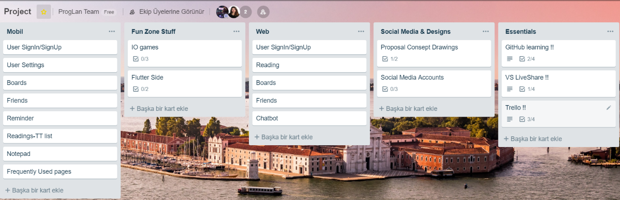

|  |  |  |  |  |  |  |  |  |  |
| --- | --- | --- | --- | --- | --- | --- | --- | --- | --- |
|  | User Adjust. | Boards | Friends | Reminder | Reading | Notepad | FunZone | Chatbot | Social Media & Design |
| Aylin | **X** | **X** | **X** | **X** | **X** | **X** |  |  |  |
| Betül | **X** | **X** | **X** |  | **X** |  |  |  |  |
| Hakan |  | **X** |  |  |  |  | **X** |  | **X** |
| Kaan |  |  | **X** |  |  |  | **X** | **X** |  |

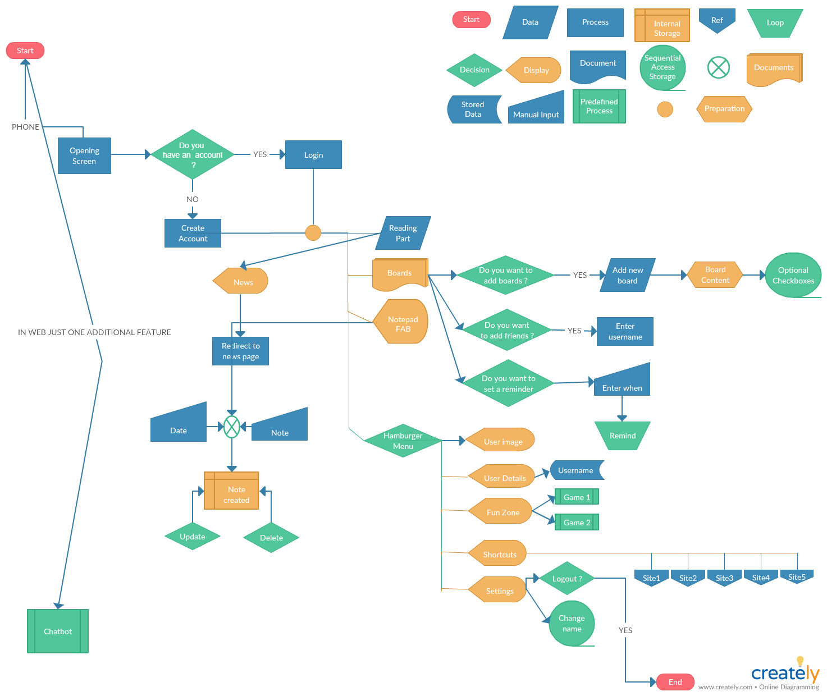

Blueprints of Mobile Application

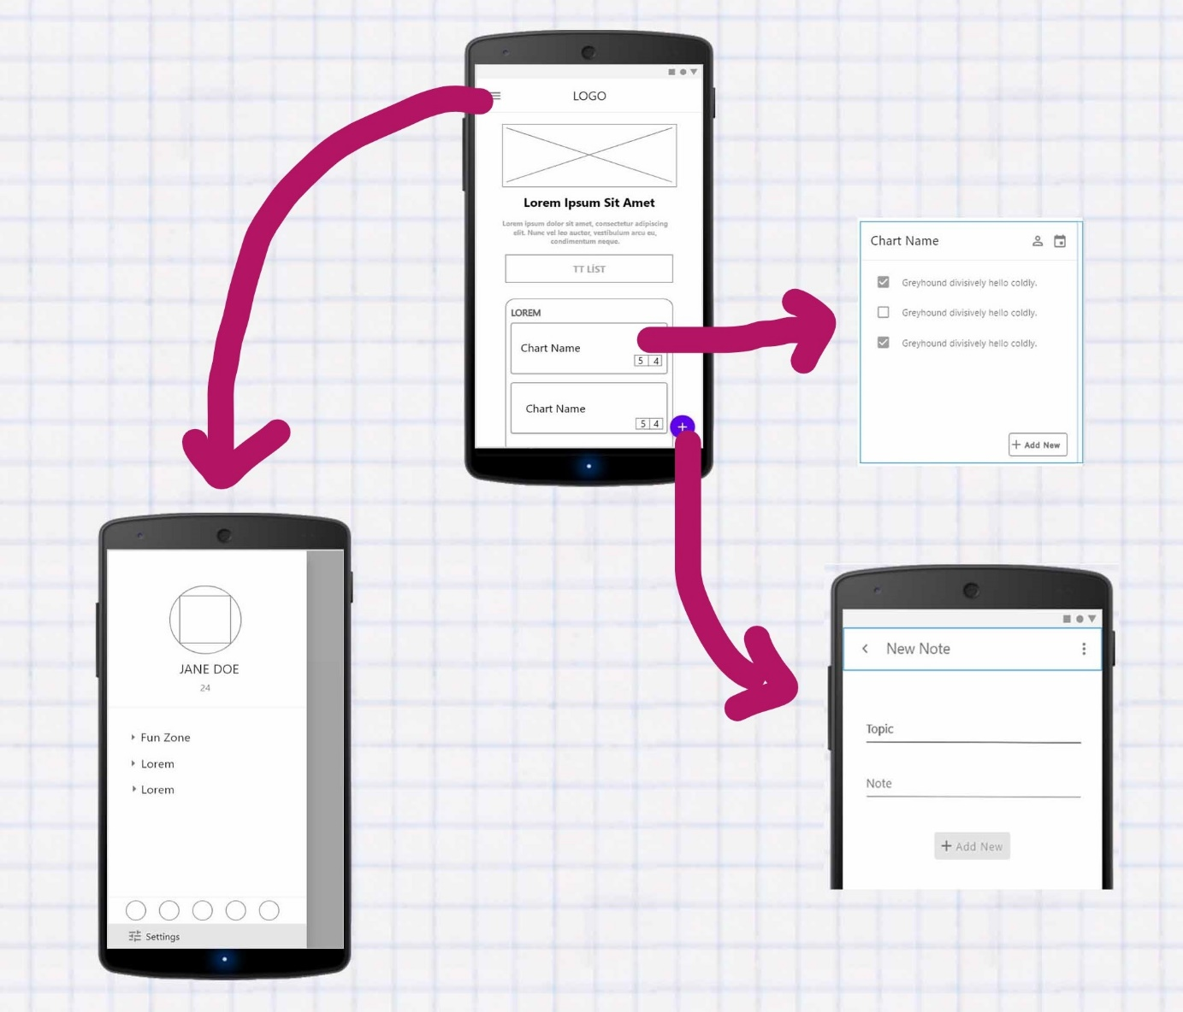

**Referances**

[1] LeanKit, What is Kanban, A Very Short History Of Kanban.

[2] <https://try.airtable.com> Accessed: 22.10.18

[3] 7 Basic Rules of Creativity You Should Know

[4] Dan Shewan,10 of the Most Innovative Chatbots on the Web,What Are Chatbots ? October 3 2018

[5] Dan Shewan,10 of the Most Innovative Chatbots on the Web, How Do Chatbots Work ? October 3 2018

[6] <https://trello.com/> Accessed: 22.10.18

[7] https://asana.com/ Accessed: 22.10.18

[8] <https://www.avaza.com/> Accessed: 22.10.18

[9] <https://clickup.com/> Accessed: 22.10.18

[10] <https://kanbantool.com/> Accessed: 22.10.18

[11] <https://www.yallahq.com/> Accessed: 22.10.18

[12] <https://feedly.com/i/welcome> Accessed: 22.10.18

[13] https://flipboard.com/ Accessed: 22.10.18

[14] <https://getpocket.com/> Accessed: 22.10.18

[15] https://www.reddit.com/r/redditmobile/ Accessed: 22.10.18

[16] https://www.google.co.uk/landing/now/ Accessed: 22.10.18

[17] <https://evernote.com/intl/tr> Accessed: 22.10.18

[18] https://www.google.com/keep/ Accessed: 22.10.18

[19] <https://products.office.com/en-us/onenote/digital-note-taking-app> Accessed: 22.10.18

[20] https://www.colornote.com/ Accessed: 22.10.18

[21] <https://www.any.do/> Accessed: 22.10.18

[22] <https://todoist.com/> Accessed: 22.10.18

[23] <https://www.wunderlist.com/> Accessed: 22.10.18

[24] <http://insomnobot3000.com/> Accessed: 22.10.18

[25] <https://roof.ai/> Accessed: 22.10.18

[26] <https://dialogflow.com/> Accessed: 22.10.18

[27] <https://www.ibm.com/watson/> Accessed: 22.10.18